Spring 2022

Duncan Street Primary Care Centre

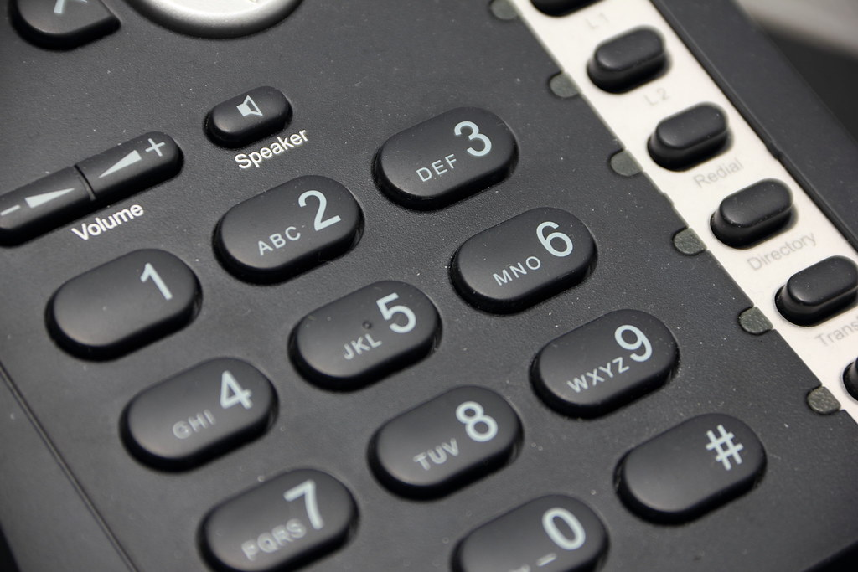
New Telephone System
The surgery has had a new phone system that has been implemented and configured so that there are various options to dial and go through to the appropriate member of the team who are always happy to help. Please listen carefully to all options available so your call can be dealt with appropriately.
Thank you for your patience during this transition period.

If you have changed any of your details such as change of address or contact number then please update your new details with the practice so that we can ensure your medical records are kept up to date.




Patient Participation Group
A vacancy has become available to join the Patient Participation Group (PPG) as the Chair of the committee. If you are interested in this role or would like further information regarding this please email in to the practice no later than 30th March to:
bcwbccg.duncanstreet@nhs.net

Please can you also contact the practice if you are currently a member of the PPG and no longer wish to be on the PPG committee list as we are currently reviewing this list.

If anyone would like to join the PPG committee and can give a few hours of their time each year to bring valuable suggestions, ideas or improvements on how we can make a difference to the practice, then we welcome all applicants to enquire via the above email or contact us in person or via the telephone.



Are your contact details up to date?
If you have recently moved house or changed your telephone/mobile number please make sure to let the surgery know so that we can update your health records.
You can change your details online on the Duncan Street Surgery Website.
With appointments now mainly being done via the telephone it is very important to make sure your contact details are correct and up to date.


New Practice Manager
Last year we saw the introduction of new Practice Manager – Denise Vaughan. As always, the practice welcomes any feedback from patients regarding services or care received.

Our current practice list size is:

10,520



Self Service Check-In

The self-service check in system is back up and running in the waiting room. We do encourage all patients to check themselves in for booked appointments using the self-service system. This ensures that patients are not stuck waiting in a queue on arrival at the surgery. We also remind patients that if you are 10 minutes late over your appointment time then you will not be seen and will have to re-book.

PTO.



Face to Face Appointments
The practice has always been open during the pandemic. If you require an appointment then face to face appointments and telephone consultations are available every day. To book any appointment please telephone the practice on:
01902 459076
And select option 1.



Late Evening Opening
Wednesday is late evening opening and we offer appointments up until 7.30pm. If you require a late appointment please just contact the practice in the usual way to book an appointment.



Missed Appointments
Any patients who book an appointment and do no turn up for the appointment will now be sent a text message or a letter. If a patient does not attend for three appointments without notifying the practice then they be taken off the list and will have to register with another GP practice.
If you are running late or are unable to attend a booked appointment then please contact the surgery by telephoning the practice and selecting option 1 on the system. By notifying us we are then able to reallocate the appointment to someone who needs it.



Feedback Welcome
As a practice we have been getting lots of positive feedback and we take onboard all comments and feedback given.

If you can spare 10 minutes of your time we can update our website on your behalf with your positive experience of the practice.


On-line Access
You can now book appointments and view your medical records online. To get on-line access just pop into the practice with photo I.D and complete an online access form. Once you are registered you will be able to access online services via the following link:
https://www.patientaccess.com

Accurx Systems
Our clinicians are now using a new system called Accurx. This allows the clinician to view photographs sent across and enable them to see what the problem may be whilst speaking over the telephone. This will help diagnose problems quicker whilst telephone triage continues.


Prescriptions
All prescriptions are now being sent via EPS. This means that the item that you order will get sent directly to a chemist. You can chose which chemist you would like your prescription to go to by contacting them directly to get yourself signed up.

Thank you from Duncan Street

Duncan Street Primary Care Centre
Blakenhall, Wolverhampton
WV2 3AN
Telephone: 01902 459076 Fax: 01902 455309
Email: wolccg.duncanstreet@nhs.net (incoming only)
Website: www.duncanstreetprimarycarecentre.co.uk

